Image carousel(carousel_slider)
Exercise #2
Flutter Developer Bootcamp

Purpose
This exercise demonstrates how to implement an image carousel in a Flutter application using the carousel_slider package.

Problem
In the provided Exercise You need to create as follows:
In the given exercise demonstrates creating an image carousel using the carousel_slider package. The main entry point runs the MyApp widget, which is a stateless widget returning a MaterialApp that houses the ImageCarousel widget.ImageCarousel, also stateless, contains a list of image URLs (imgList) and builds a Scaffold with an AppBar titled "Image Carousel". The body centers a CarouselSlider widget configured for automatic sliding, responsive aspect ratio, and enlarging the center image. The CarouselSlider maps each URL in imgList to a Container with an Image.network that displays the image with BoxFit.cover.

How to Solve
1. Checkout the exercise from Git Repo:
git clone -b <user-branch> <repo-URL>
2. Open the root folder inside VS Code
3. To build the app click the run option in the main method{}
4. Import Required Packages
- import 'package:flutter/material.dart';
- import 'package:carousel_slider/carousel_slider.dart';
5. Demonstrates creating an image carousel in Flutter.
6. Shows image loading from the network.
7. Implements responsive design with aspectRatio and BoxFit.cover.
9. Go To File: <specific-file-with--method> à <method-name>, implement your logic.

You will Achieve
When you complete this Exercise you will learn the following:
Imports:
- package:flutter/material.dart: Provides Flutter’s core components and material design elements.
- package:carousel_slider/carousel_slider.dart: Provides the CarouselSlider widget for creating carousels.
Widgets:
- MaterialApp: Wraps the entire app, providing material design elements.
- Scaffold: Provides a layout structure with an AppBar and body.
- AppBar: Displays the app bar with the title "Image Carousel".
- Center: Centers its child widget within itself.
- CarouselSlider: Creates the image carousel with various configuration options.
- Container: Contains each image within the carousel.
- Image.network: Loads and displays images from the provided URLs.

Screenshots

Expected output(carousel-slider)

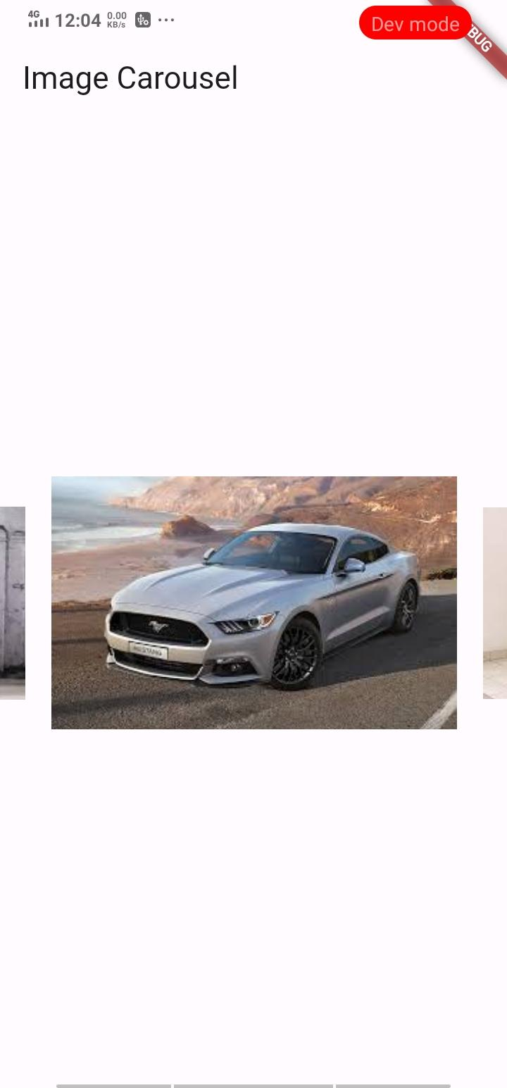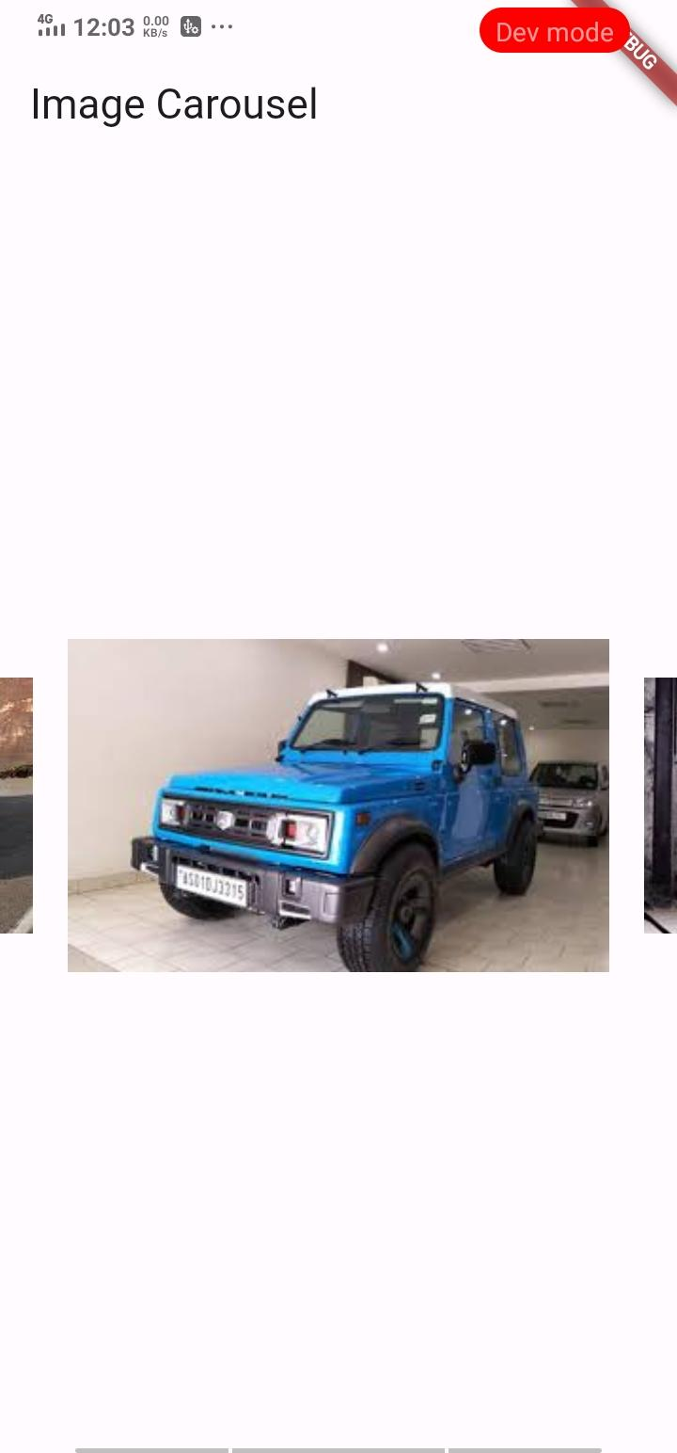
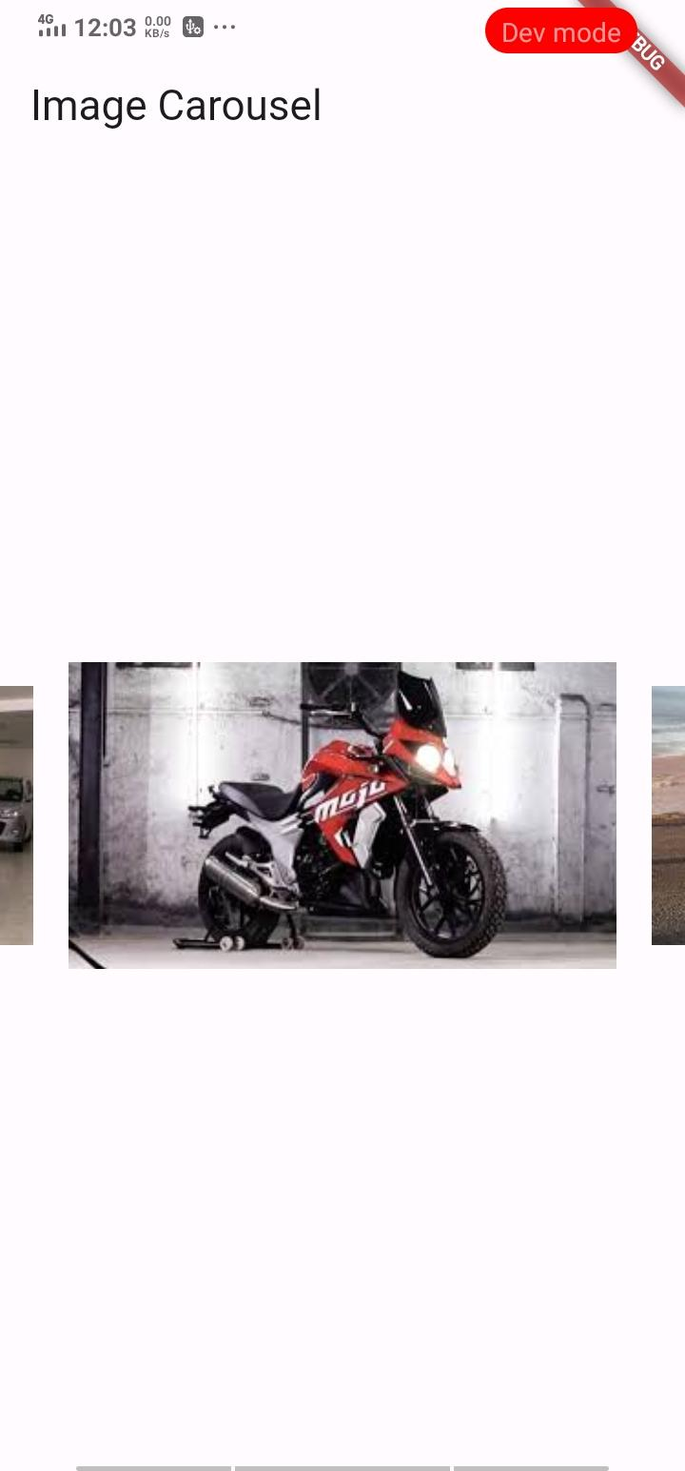

How to submit your Exercise
Push your project back to the same git branch using command:
<command name>

Happy Coding!

